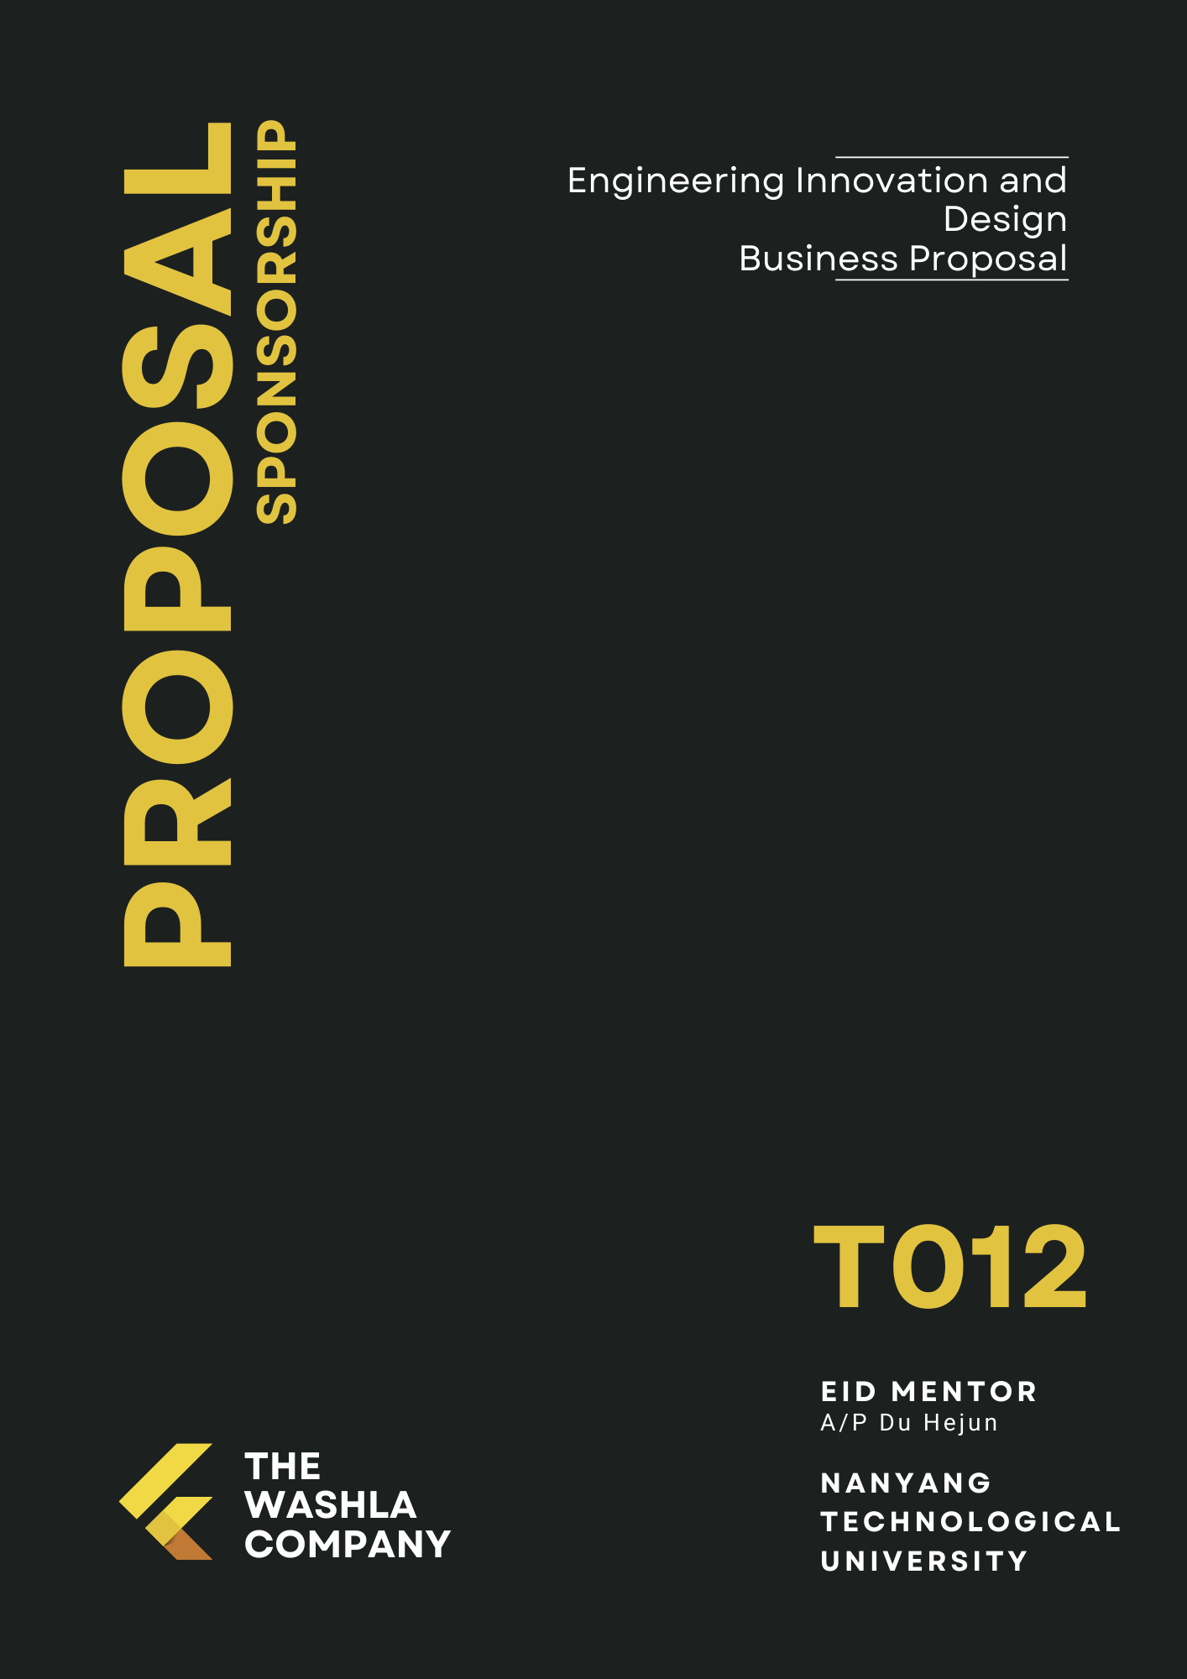

# **Executive Summary**

No one likes a dirty toilet. No matter the establishment, big or small, there will always be one thing they have in common - washrooms. In a place where food is handled and consumed, cleanliness is critical. In a time when the world is facing a pandemic, it is imperative to maintain the cleanliness of the washroom, for both hygiene and appearance purposes.

With such prevalence for a need for clean toilets everywhere, our company has created a product that is able to handle the sheer volume of toilets everywhere while guaranteeing cleanliness and hygiene. By leveraging technology, this improves the productivity of cleaners as well.

Our company aims to streamline the process of cleaning washrooms while still being able to give toilet users a sense of assurance and that toilets are clean. While cleaners provide a certain service, it also presents another issue: perception of hygiene is subjective and can have varying standards. With WashLa, we are able to provide a standard for cleanliness that guarantees users that their toilets have undergone proper sanitation.

WashLa is a modified toilet seat that cleans the toilet before usage. Equipped with sensors that help automate the whole cleaning process, our product is simple in design; and is meant to be adapted for existing toilets. From installation to training and maintenance, hawker centre operators will realise that our system is simple, convenient and cheap.

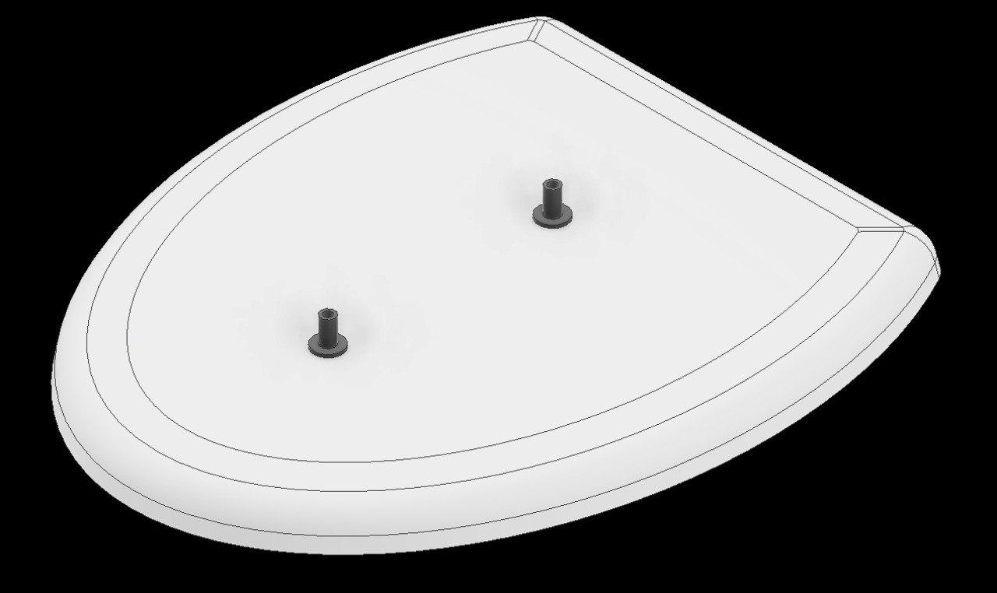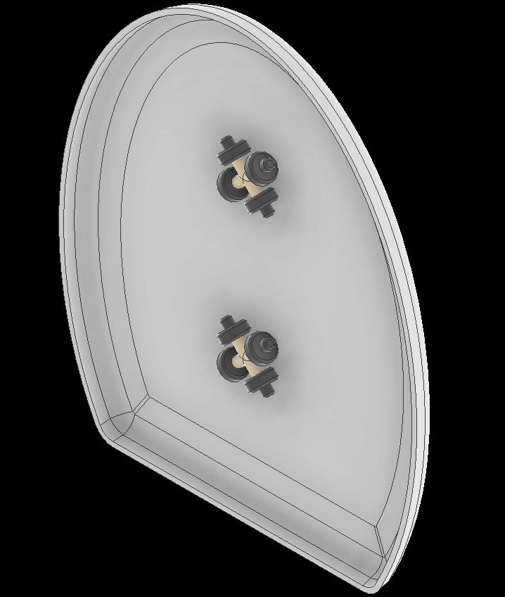

Our primary market are public and private operators of Coffee Shops and Hawker Centres, as the toilets located there have the lowest levels of satisfaction in toilet cleanliness, according to a study done by Singapore Management University.

Before we approach our potential customers, we intend to reach out to the Restroom Association of Singapore, to seek their support for our product. Securing their support will enable our product to stand out in the market and give us credibility when pitching to NEA and other private companies.

Firstly, we intend to pitch our products to NEA. Our strategy is to offer a collaboration with our company where the main goal is to improve the overall satisfaction of toilet cleanliness in hawker centres. Secondly, should we be successful in our trial run, we will further our business plans with NEA and start pitching to private coffee shop operators. Lastly, while our initial focus is NEA and the coffee shop operators, we intend to expand our target customer segment to the management of venues where toilets have similarly low levels of satisfaction of toilet cleanliness. In the future, we may approach mall operators such as CapitaLand and Frasers Property.

Presently, WashLa has completed initial development: the preliminary stage and has created a prototype. The initial funding of $144,200 will be sufficient to carry WashLa through to initial profitability. These financial needs will be met through a blend of bank loans, equipment leases and personal cash investment. We anticipate that we will be able to sustain minimum gross margins of 36%. As sales are projected to grow over the course of the subsequent month as brand awareness increases and marketing costs reduced which will allow us to incur profits by the third month. We further anticipate that, after our initial year of operation, we will be able to sustain a net return of sales of 16%-17% – higher than current industry averages. Furthermore, with the level of performance, we anticipate expanding our presence outside Singapore to other countries after 2 years.

# 

# **Table of Contents**

# 

1. **Executive Summary** **2**
2. **Table of Contents** **4**
3. **Business Description** **5**
   1. Company & Mission
   2. Company Product
   3. Management Team (Org Structure and Responsibilities)
   4. Industry Overview
4. **Market Analysis 8**
   1. Target Customer Segment
   2. Competitor Analysis
   3. Product Value Proposition
   4. Estimated Sale
5. **Development & Production** **15**
   1. Development Status
   2. Production Process
   3. Cost of Production (Labour and Financial)
6. **Sales & Marketing** **17**
   1. Marketing Strategies
7. **Financ****es 20**
   1. Risk Assessment
   2. Funding Requests & Returns
   3. Capital Equipment & Supply list
   4. Balance Sheet
   5. Breakeven Analysis
   6. Cash Projections
8. **Appendixes & References 23**

# 

# 

# **Business Description**

## Industry Overview

While Singapore claims to be a “Clean & Green” city, its public spaces are often cleaned by numerous janitors. This is especially so regarding public toilets which have been found to lack standards of hygiene based on the Public Cleanliness Satisfaction Survey done in 2021 by Singapore Management University (SMU). Among the various establishments where public toilets can be found, the coffeeshops and hawker centres had the least proportion of respondents satisfied with its toilet cleanliness at 61.3% and 67.5% respectively. More than half of the respondents cited dirty or stained toilet seats as the most common issue.

Relating to the results of the study and feeling frustrated from our own personal experiences, the team has decided to empower public lavatories users with the ability to optimally clean the dirty toilet seat without having to wait for the routine cleaning or potentially dirtying themselves while sanitising the seat.

## Company & Mission

Our company is a Singapore based start-up company that is determined to revolutionise toilet cleanliness by innovating new designs and solutions for our customers and the general public. Founded in 2022 by highly innovative and skilled students in NTU, we aim to accentuate the problem of dirty toilets and tend to people’s need for a readily available clean toilet for them to use whenever. We aim to distribute our product to public toilets as they are the least maintained and dirtiest and eventually throughout Singapore, and will be supported by marketing and advertising strategies. We are determined to provide the best solution to having clean and ready toilets to be used and we will never stop innovating new ideas to provide a better solution possible.

## Company Product

Our team has created WashLa, a toilet seat cleaner that sprays anti-bacterial solution onto the toilet seat. Equipped with sensors, the system will be able to detect if the seat cover is up or down. The image below (Fig.1) depicts the company’s working prototype.

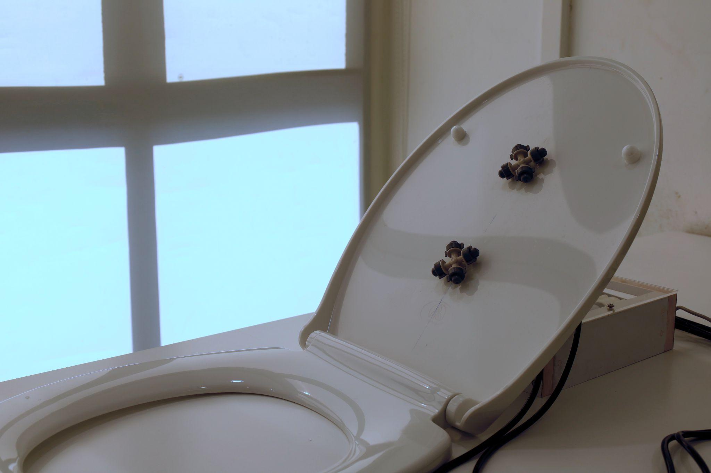

Fig.1: WashLa

When the seat cover is lowered down, the ultrasonic sensor will detect and start the cleaning process. During which, the LED light attached by the side turns from green to red, to indicate the start of the process. Anti-bacterial solution will be pumped through the nozzle and sprayed onto the toilet seat. Upon completion, the led light will turn green to indicate that the cleaning process is completed and the user will be able to use the toilet. The image on the left (Fig.2) depicts the pump and electronics and the image on the right (Fig.3) depicts the sensor’s position relative to the toilet seat.

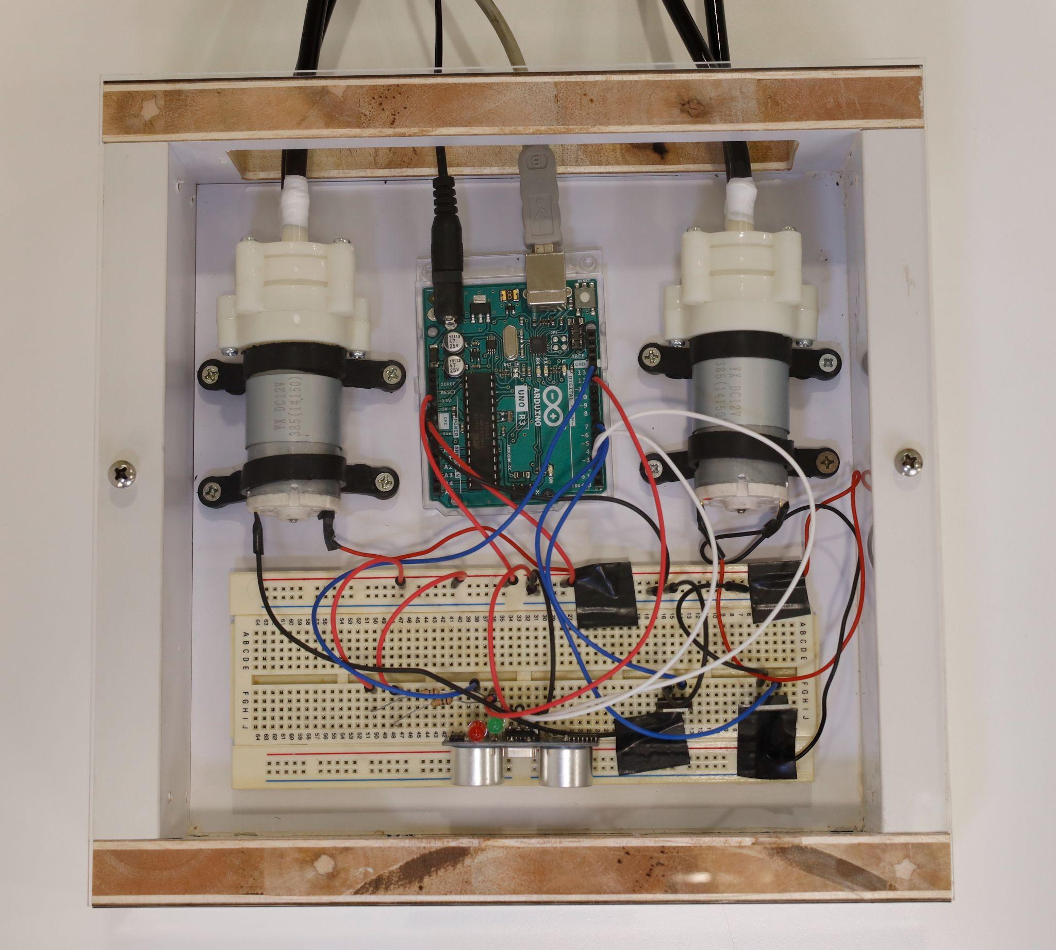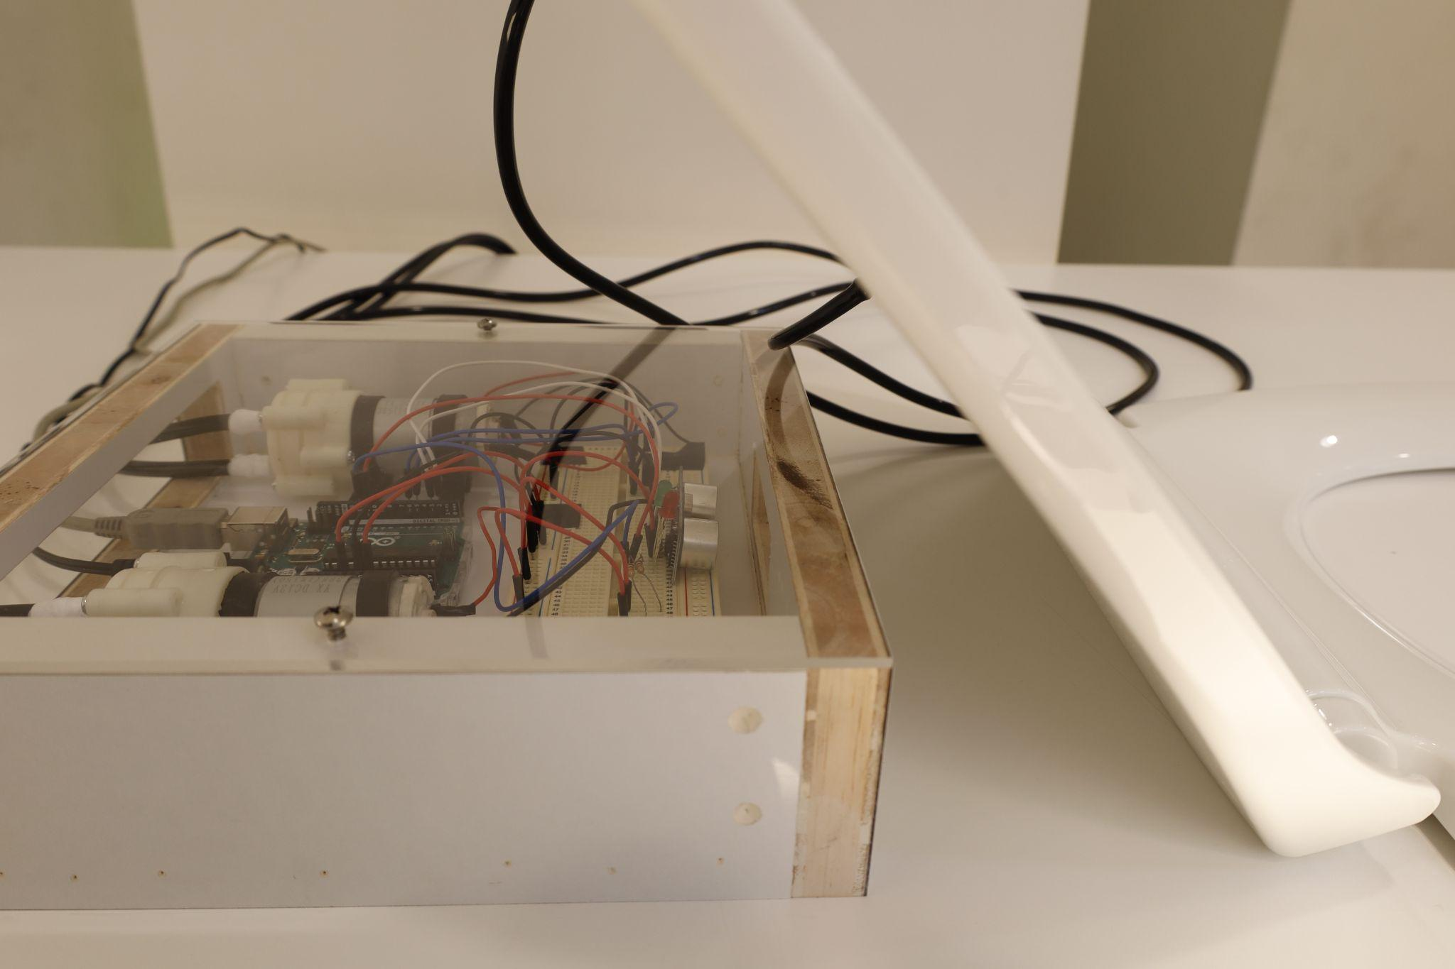

Fig. 2: Pump, Sensor & Arduino Fig. 3: Sensor Position

This product targets toilets located in Coffee Shops and Hawker Centres with low satisfaction in toilet cleanliness as found in the survey. Our main audience is the Coffee Shop operators and National Environment Agency (NEA) under the parent Ministry of Sustainability and the Environment (MSE), Housing and Development Board (HDB) and JTC Corporation.

## **Management Team**

Every individual is responsible for each section. The Chief Executive Officer is responsible for the management of WashLa and appoints the members of the executive management team, which is made up of individuals responsible for the joint group functions. Our team is mainly divided into two departments: Design & Manufacturing and Finance & Marketing.

**Koh Weiheng**

*Chief Executive Officer*

* Head of the company, responsible for overseeing the company’s strategic direction.
* Plays an active role in implementing strategic plans that promote the company’s mission and vision.
* Oversees both the Design & Manufacturing Department and Finance & Marketing Department.
* Key leadership of the team. Responsible for the efficiency of businesses.

Design & Manufacturing department:

**Georemon Russelraj**

*Chief Design and Manufacturing Officer*

* Works with engineers, clients and marketing staff, improving the product’s design and lowering the cost.
* Responsible for the daily operations of the company, ensuring that business operations are efficient and effective through proper management of resources.

|  |
| --- |

***Ng Jun Kai, Shawn***

*Manufacturing officer*

* Responsible for the manufacturing process, product conception and development.
* Ensures all products conform to the company’s quality standards.

**Tie Jie En**

*Web and Graphics Designer*

* In-charged of web and graphics designs for the product, such as 3-D modelling.
* Responsible for improving the design and efficiency of our existing products.

Finance & Marketing department:

**Muhammad Baqir Bin Amir**

*Chief Finance Officer*

* Responsible for budget management, forecasting needs and the securing of funding.
* Responsible for all the day-to-day transactional accounting for the business. (Include tracking of all transactions)

**Wong Xing Han Lincoln**

*Development Officer*

* In-charged of supporting the organisation's financial well-being.
* Ensures that the manpower requirements of the company are fulfilled.
* Responsible for understanding the trends of the company’s field of specialty and developing business proposals for existing and new customers.

**Marcus Neo Zi Chao**

*Management and Quality Assurance Officer*

* Organises operations and procedures.
* Controls correspondence and responsible for the liaising and negotiation with suppliers, retailers and consumers.

**Du Weifang**

*Finance and Funding Officer*

* In-charge of cost benefit analysis.
* Developing a strong network of funding contacts.
* Preparing reports, financial data, statistical information, returns whenever necessary and report the findings to the partnership.

**Daniel Loh Guang Yi**

*Business Development Officer*

* Responsible for developing marketing and business plans for achievement of revenue goals for the company.
* Entails participating in media communication activities for the company.
* Making and communicating with business contacts.

# 

# **Market Analysis**

## Target Customer Segment

Based on the Public Cleanliness Satisfaction Survey done by Singapore Management University (SMU) in 2021, results showed that coffee shops and hawker centres had the least satisfaction among respondents regarding toilet cleanliness, when compared to toilets in other locations such as at Shopping Malls and MRT Stations. Additionally, many cite dirt or stained toilet seats as the main issue for their dissatisfaction.

To address this issue of low public satisfaction with toilet cleanliness at coffee shops and hawker centres, WashLa’s target customer segment are the coffee shop and hawker centre operators, in a bid to help them improve public satisfaction of their toilets.

Coffee shops are managed by private companies who often have a chain of outlets. The more prominent companies are Kimly Group, Fu Chan F&B Group, Broadway Group. On the other hand, hawker centres are managed by the Hawker Centres Group (HCG) of Singapore’s National Environment Agency as well as the individual Town Councils of each estate in Singapore.

Private companies and public agencies will have differing agendas. Private companies may aim at making profits while public agencies may aim to keep food affordable for Singaporeans. While the aims may be different, the common concern is the operating cost of the establishments which is critical in maintaining profitability and keeping food prices affordable. This is especially important during a period of inflation and rising costs such as the present.

More is needed to be done with the current state of toilet cleanliness at our food establishments. Even while operators desire to keep non-food operating expenses low, the current state of toilets poses a health risk to their customers and even affects the reputation of the establishment. The health of customers and hygiene levels of toilets need to be improved in the long run for the food establishments to sustain because if neglected, it can deter customers from patronising their establishments. Thus, affecting their ability to run the business.

Currently, the food establishments often employ external cleaning companies to clean the toilets routinely. In the case of hawker centres, it may even be closed for a few days in order to carry out thorough cleaning of the entire venue. This is ineffective and costly considering the high volume of footfall that the places see daily. Once someone has dirtied the toilet seat, many people would avoid it until after it is cleaned and this cleaning may only take place the next day. Hence, many companies including ours have designed solutions to empower users in taking charge of their hygiene or even eliminating the need for the user to dirty their hands.

## 

## Competitor Analysis

Current products in the market that sanitise toilet seats can be classified into 2 categories: (1) Toilet Seat Cleaners and, (2) Automatic Toilet Seat Cleaners

### **(1) Toilet Seat Cleaners**

The first category are toilet seat cleaners that require users to manually clean the toilet seat. Companies such as Initial and Calfarme produce antibacterial solutions and dispensers to contain them. These dispensers are then placed in the toilet where users can use them to dispense the solution onto toilet paper and then wipe the seats.

|  |  |
| --- | --- |
| ***Calfarme’s Foam Care Antibacterial Solution and Dispenser*** | ***Initial’s Antibacterial Solution Dispenser*** |

| Pros | * Simple and Intuitive |
| --- | --- |
| Cons | * Requires users to manually clean the surface, which can be unhygienic. |

### **(2) Automatic Toilet Seat Cleaners**

The second category are automated systems that clean the toilet seat either before or after the toilet is used. These systems remove the need for users to physically wipe the seat with their hands while effectively cleaning the seat for the next user.

|  |  |  |
| --- | --- | --- |
| ***Emtra’s CWS Paradise Toilet Clean Seat Universal*** | ***SpinX’s Toilet Cleaning Robot*** | ***Hering’s Automatic Cleaning Toilet*** |

| Pros | * An all-in-one, integrated system * Effective Cleaning * No need for users to manually wipe the seat. |
| --- | --- |
| Cons | * Expensive, cost can be approximately 10-20 times more expensive than WashLa. * Maintenance can be difficult as the cleaning mechanism is built within the system. * Difficulty in installing as the whole toilet bowl has to be replaced. |

## Product Value Proposition

Hawker Centres that have antibacterial solution dispensers require toilet users to dispense the solution onto toilet paper and wipe the seat. This can be extremely unhygienic if the seat is badly stained with dirt or urine.

With WashLa, the toilet user’s experience is greatly enhanced as users do not need to manually clean the seat as technology is leveraged to automate the process. This makes the entire process more hygienic and convenient.

While conceptualising and developing our prototype, our engineering team had managed to design a product that is simple in design. Our product is one that is meant to be adapted for existing toilets, meaning that operators do not need to buy an entirely new toilet and the product is adapted to existing toilets. From installation to training and maintenance, operators will realise that our system is simpler, more convenient and cheaper.

This allows for ease of training, maintenance and brings about savings in the long run. From the idea of minimising costs at all stages of development and design, the savings are brought forward and with the product costing less than 15% than our competitors, our product is definitely more competitive and worthwhile.

## 

## Estimated Sales

The prominent coffee shops operators, NEA and the various Town Council manage many food establishments that can be found in housing estates and private commercial areas throughout the island. The tables below show the number of coffee shops and hawker centres managed by the respective parties.

Private Coffee Shop Operators

| **Name of Operator** | **Quantity of Coffee Shops** |
| --- | --- |
| Kimly Group | 83 |
| Fu Chan Group | 22 |
| Broadway Group | 23 |
| Total | 128 |

Public Hawker Centre Operators

| **Name of Operator** | **Quantity of Hawker Centres** |
| --- | --- |
| NEA | 26 |
| Various Town Councils | 81 |
| External Organisations | 7 |
| Total | 114 |

As hawker centres are typically larger in size compared to coffee shops, they will have more toilet bowls and thus, will require more of our product to upgrade their toilets.

Assuming that the customers intend to completely upgrade their toilets and that the coffee shops and hawker centres require 4 and 8 of our products to completely upgrade their toilets respectively, the table below shows the estimated sales.

| **Type of Establishment** | **Quantity of Product** |
| --- | --- |
| Coffee Shops | 512 |
| Hawker Centres | 912 |
| Total | 1424 |

This projected sales does not take into account the smaller Food and Beverage companies that also manage coffee shops in Singapore as well as the other customer segments that we intend to pursue.

Furthermore, private coffee shop operators can tap into NEA’s Toilet Improvement Programme’s Co-funding support, which cofunds 90% of the cost for upgradings of toilets, incentivising them to purchase our products which is the cheaper alternative to what is currently on the market.

After our initial launch, the company intends to target the home owners and mall operators to purchase our products and utilise them in their own bathrooms or washrooms. This will further expand our market and increase our sales further.

# 

# 

# **Development & Production**

## Development Status

| **Development Stages** | **Status** |
| --- | --- |
| Market Research &  Brainstorming of Preliminary Idea | Completed |
| Design and  Prototyping Conceptual Design | Completed |
| Working Prototype | Completed |
| Finalise Design | May 2022 |
| Sourcing of Manufacturers and Raw Materials | June 2022 |
| Testing of Final Product | June 2022 |
| Patent | To file for patent in June 2022 |
| Mass Production | July 2022 |

The company has completed the initial research and gone through iterations of development prototyping. One of the major design decisions is the centralised spray nozzle design instead of the ring of spray nozzle design. The centralised spray nozzle design reduces the number of components and translates to lower costs. However, this design relies more on nozzles for the effectiveness of cleaning the seat and during our prototyping, the addition of more nozzles makes up for the effectiveness and there was no overall drop in effectiveness.

Various methods of coding and electronic components have also been tested. The main aim is to achieve the most efficient code that uses the least memory. Another important factor to consider is the use of electronic components as efficiently as possible. Efficiency can be measured by the number of components that are required to achieve the same task. The lesser the amount of components used, the greater the efficiency which in turn leads to a lower cost of production as lesser components are required. The current configuration of electronic components allows the company to achieve the intended task with the least number of electronic components with the most efficient code with the code done using C++.

Currently, the company has a working prototype. We will finalise the design for mass production after trial runs and seeking opinions from various stakeholders such as the Restroom Association of Singapore. The company will then source for manufacturers to fabricate a sample of the Final Product. This Final Product will be tested for its usability and effectiveness in cleaning the toilet seat. It will also be stress tested for reliability and durability before it is determined whether to begin mass production.

Subsequently, we begin the process to file for a patent. Concurrently, mass production will begin with quality checks to ensure the manufactured products meet the durability and required effectiveness of cleaning the seats.

## Production Process

Production Process will be about the manufacturing processes used for mass production.

Compression Moulding will be used to form the Urea-formaldehyde Toilet Seat. Compression Moulding is chosen for its ability to handle the larger amounts of raw material needed to form larger or thicker parts. Compression Moulding also has lower setup cost and thus a lower manufacturing overhead cost. Hence, Compression Moulding is the process chosen for the manufacturing of the Toilet Seat.

Plastic Injection Mould will be used to form the Polypropylene Spray Nozzle. Compression Moulding is chosen for its precision and high-output production. The precision is required for effectiveness of the Spray Nozzle. It also has low labour cost requirements.

A microcontroller is required for the automatic operation of the product. In order to achieve this, an Arduino UNO R3 is used for the prototype. However to reduce the cost as well as improve the efficiency of the overall system, a dedicated Printed Circuit Board (PCB) can be used for mass production instead. The required electronic components for the circuit can also be integrated to the PCB in a more compact housing as compared to the prototype which will further reduce the cost of production while enabling the system to be more compact and efficient.

## Cost of Production

| **Costs** | | **Price per unit** |
| --- | --- | --- |
| Compression Moulding for Toilet Seat | | $25 |
| Injection Moulding for Nozzle (x2) | | $2 |
| Purchase | Pump (x2), Tubings & Fittings | $40 |
| Electronics, Sensors & Wires | $15 |
| Labour Costs: Assembly, Packaging | | $15 |
|  | Total: | $92 |

# **Sales & Marketing**

## Marketing Strategies

Before we approach our potential customers, we intend to reach out to the Restroom Association of Singapore, to seek their opinion and support for our product. Securing their support will enable our product to stand out in the market and give us credibility when pitching to NEA and other private companies.

Firstly, we intend to pitch our products to NEA. Our strategy is to offer a collaboration with our company in which the main goal is to improve the overall satisfaction of toilet cleanliness in hawker centres. To prove the benefits of our product, we will sponsor several WashLa products as a trial in selected hawker centres for a duration of 3 months. As an indicator of the performance of this collaboration, we will install small touch screens at the entrance of the toilets for users to indicate their rating on our products. This will serve as a key performance indicator so as to convince NEA about the viability and practicability of our product.

Secondly, should we be successful in our trial run, we will further our business plans with NEA and start pitching to private coffee shop operators. The approach will be similar. Should the private coffee shop operators be keen to trial our products, we will likewise offer the same trial offering for NEA, to the private operators. Thereafter, we will monitor our products for 6 to 12 months and make improvements and adjustments to our products.

Lastly, while our initial focus is NEA and the coffee shop operators, we intend to expand our target customer segment to the management of venues where toilets have similarly low levels of satisfaction of toilet cleanliness. These places include outdoor parks managed by National Parks Board (NParks) and MRT Stations managed by SBS Transit and SMRT. In the future, we may approach mall operators such as CapitaLand and Frasers Property.

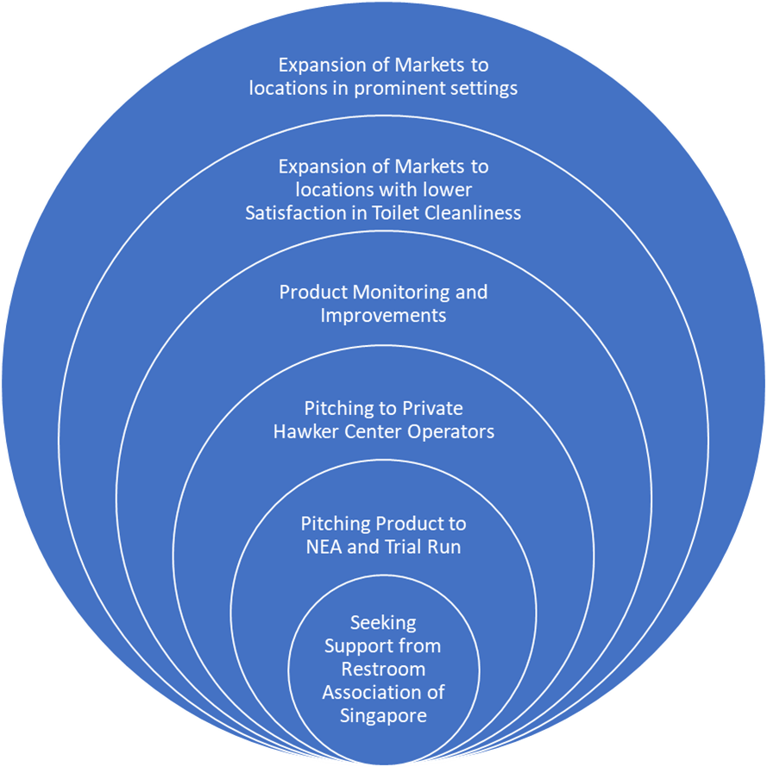

*WashLa’s Market Expansion Strategy*

### Pitching of WashLa

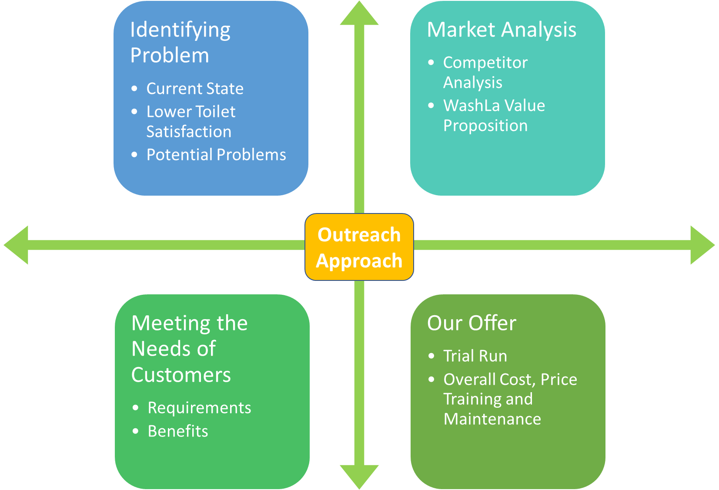

*WashLa’s Overall Pitching Approach to Public and Private Hawker Centre Operators*

**Identifying Problem**

* Low Public Satisfaction with Toilet Cleanliness in Coffeeshops and Hawker Centres
* Most common issue is Toilet Seats / Urinals being dirty or Stained
  + Bad Odour which can be attributed to dirty Toilet Facilities.
* Low Public Satisfaction leads to lower reputation of Hawker Centre, which can impact businesses
  + A Hawker Centre that has dirty toilet facilities can be linked with poor hygiene standards of the food establishment, which can deter people from patronising
  + With emphasis of hygiene especially during COVID-19 Pandemic period, it does not reflect well of the establishment

**Market Analysis**

* Existing products for an all in one toilet in the market are expensive, difficult to maintain and install
* Existing Toilet Seat Cleaners are Dispensers that dispense antibacterial solution where users are required to wipe the seat
  + This can be unhygienic especially if the seat is badly stained
  + This can be cumbersome and troubles the users
* WashLa Value Proposition
  + WashLa is a cheaper alternative to all products in the market, which is a product that is adapted to existing toilets.
  + Cheaper and easier to maintain

**Meeting the Needs of Customers**

* Requirements
  + A product that can raise the hygiene levels of toilets
  + A product that can improve public satisfaction with toilet cleanliness
  + A product that is inexpensive
  + A product that is easy to be used by toilet users
* Benefits
  + Improved toilet cleanliness as users are able to clean the toilet seat without having to manually clean the surface
  + Improved toilet experience as the cleaning process is automated
  + Improved reputation of Hawker Centre as product is a relatively new / unseen in Singapore

**Our offer**

* Trial Run
  + 3 Months Trial Run of Installation, Maintenance and Training at selected outlets
* WashLa
  + Competitive price which is less than 15% the cost of our competitors
  + Ease of installation and maintenance
  + Able to meet the needs of customers by improving hygiene levels of toilets, public satisfaction and low cost

# 

# **Finances**

## Risk Assessment

### Economic risks

Our company anticipates several Economical Risks associated with current events ongoing in Singapore and the world.

Our company expects labour costs to increase as the Singapore Government is tightening restrictions on foreign labour. With the Russian Invasion of Ukraine, oil prices have since gone up and this will raise the cost of materials as they are imported into Singapore. With countries undergoing various spikes in the number of COVID-19 cases and countries going into lockdown, this can also impact the material and shipping cost.

The Economical Risks faced by our Company are very dynamic and are dependent on current events and trends and to mitigate the impacts, the company intends to use its existing capital to cushion economical risks.

### Operational risks

Our company also expects Operational Risks to be dynamic and hard to predict as they can occur unexpectedly. We can expect shipping delays of our materials which can delay our manufacturing and delivery of products. With a tight labour market in Singapore and should our product be well received, our company might face difficulty in manufacturing, to meet the demands of the market.

To mitigate the Operational Risks, our company intends to order more materials per shipment, so as to have more than enough supply of materials at any point of time. Also, to deal with high demand in manufacturing, we intend to hire more short-contract / part time workers to complement our existing workforce, should we see demand for our product go up.

## 

## Capital Equipment & Supply list

| **Capital Equipment & Supply List** |  |
| --- | --- |
| Intellectual Properties | S$24,000 |
| Factory and Plant | S$20,000 |
| Wages/per month | S$17,500 |
| Utilities/per month | S$10,000 |
| **Supplies** |  |
| Toilet Seat | S$1,900 |
| Nozzle(x2) | S$3,200 |
| Pump(x2), Tubings & Fittings | S$2,000 |
| Electronics, Sensors & Wires | S$3,000 |
| Anti-Bacterial Solution | S$2,400 |
| Packaging | S$1,000 |
| **Total:** | S$13,500 |

## 

## Balance Sheet

| **Assets** |  | **Liabilities** |  |
| --- | --- | --- | --- |
| **Current Assets:** |  | Long Term Debt | S$ 41,300 |
| Cash | S$ 100,500 |  |  |
| Petty Cash | S$ 300 |  |  |
| Inventory | S$ 11,000 | **Shareholders’ Equity** |  |
| Supplies | S$ 31,000 | Preferred Stock | S$ 53,000 |
| Total Current Assets | S$142 ,800 | Common Stock | S$ 49,000 |
|  |  | Total Shareholders’ Equity | S$ 102,000 |
| Goodwill | S$ 500 |  |  |
|  | S$ 500 |  |  |
|  |  |  |  |
| **Total** | S$ 143,300 |  | S$ 143,300 |

## 

## 

## Funding Requests & Returns

WashLa is a new cleanliness company that will set itself apart from other cleanliness in Singapore by innovating new designs and solutions for our customers and the general public. This magazine “superstore” will also offer a variety of candies, snacks and high-end tobacco products (imported cigarettes, cigars, etc.). Its target customers are a mix of Coffee Shop operators and National Environment Agency (NEA) under the parent Ministry of Sustainability and the Environment (MSE), Housing and Development Board (HDB) and JTC Corporation.

We have established that the following are our financial needs:

| **Request** | **Cost** |
| --- | --- |
| Capital/ Equipment Needs | S$56,000 |
| Start-up Inventory | S$20,200 |
| Prepaid Expenses & Deposits | S$11,000 |
| Miscellaneous Start-Up Costs | S$42,000 |
| Materials | S$10,000 |
| Marketing & Promotional | S$5,000 |
| **Total:** | **S$144,200** |

Presently, the initial funding of $144,200 will be sufficient to carry WashLa through to initial profitability. These financial needs will be met through a blend of bank loans, equipment leases and personal cash investment.

Furthermore, We anticipate that we will be able to sustain minimum gross margins of 36%. We will seek to increase this level through management of our inventory and sourcing. We further anticipate that, after our initial year of operation, we will be able to sustain a net return of sales of 16%-17% – higher than current industry averages.

Furthermore, with the level of performance, we anticipate expanding our presence outside Singapore to other countries after 2 years.

## 

## Cash Projections

# Our proposed cash flow projection forecast is summarised in the tabulated chart.

|  | **January** | **February** | **March** | **April** | **May** |
| --- | --- | --- | --- | --- | --- |
| **Sources of Cash** | - | - | - | - | - |
| Receivable collections | S$10,000 | S$21,000 | S$25,000 | S$14,000 | S$17,000 |
| Customer Deposits | S$23,000 | S$34,000 | S$30,000 | S$20,000 | S$22,000 |
| Loans from the bank | - | - | S$10,000 | - | S$14,000 |
| Other | - | S$10,000 | - | S$10,000 | - |
| **Total Cah Sources** | **S$33,000** | **S$65,000** | **S$65,000** | **S$44,000** | **S53,000** |
| **Uses of Cash** | - | - | - | - | - |
| Payroll,Tax & Benefits | S$10,000 | S$11,000 | S$10,000 | S$20,000 | S$13,000 |
| Vendor Payments | S$40,000 | S$23,000 | S$25,000 | S$10,000 | S$23,000 |
| Rent | - | - | - | S$10,000 | S$12,000 |
| Insurance | - | S$1,000 | - | - | S$4,000 |
| Debt Service | - | S$32,000 | - | - | - |
| Other | - | - | - | - | - |
| **Total Uses of Cash** | **S$50,000** | **S$67,000** | **S$35,000** | **S$40,000** | **S$52,000** |
| **Monthly Net Cash Flow** | **S$(-17,000)** | **S$(-2,000)** | **S$30,000** | **S$4,000** | **S$1000** |
| Beginning Cash Balance | S$20,000 | S$3,000 | S$1,000 | S$31,000 | S$35,000 |
| **Ending Cash Balance (Deficit)** | **S$3,000** | **S$1,000** | **S$31,000** | **S$35,000** | **S$36,000** |

# **Appendixes & References**

Ink.library.smu.edu.sg. (n.d.). Retrieved May 9, 2022, from https://ink.library.smu.edu.sg/cgi/viewcontent.cgi?article=4599&context=soss_research

*Overview*. National Environment Agency. (n.d.). Retrieved May 9, 2022, from https://www.nea.gov.sg/our-services/hawker-management/overview

*Markets / Hawker Centres - nea.gov.sg*. (n.d.). Retrieved May 9, 2022, from https://www.nea.gov.sg/docs/default-source/hawker-centres-documents/list-of-hcs_-1-apr-2022.pdf

*News releases*. National Environment Agency. (n.d.). Retrieved May 9, 2022, from https://www.nea.gov.sg/media/news/news/index/launch-of-nea-s-toilet-improvement-programme

*CWS paradise toilet clean seat universal*. CWS Paradise Toilet clean seat Universal - 4560000 | Emtra Hygiene Services. (n.d.). Retrieved May 9, 2022, from https://www.emtra.eu/en/cws-paradise-toilet-clean-seat-universal/

*Spinx - world's first toilet cleaning robot*. Kickstarter. (2020, June 28). Retrieved May 9, 2022, from https://www.kickstarter.com/projects/1209829383/spinx-worlds-first-toilet-cleaning-robot

Automatic Cleaning Systems. (n.d.). Retrieved May 9, 2022, from https://www.heringinternational.com/en/products-services/public-toilet-facilities/equipment/cleaning/